**Practical – 3**

**Aim:- Configuring IBGP and EBGP Sessions, Local Preference, and MED**

**Topology:-**

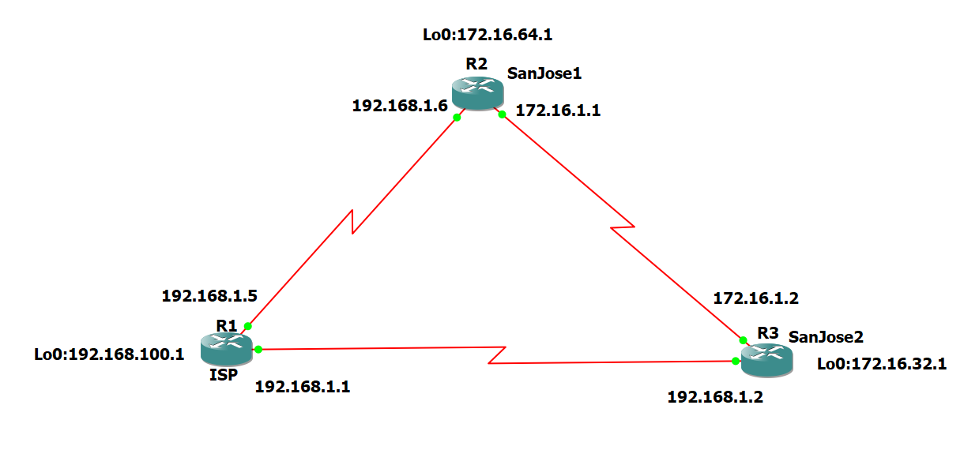

Step 1: Configure interface addresses.

**R1 Console**

conf t

hostname ISP

interface Loopback0

ip address 192.168.100.1 255.255.255.0

exit

interface Serial1/0

ip address 192.168.1.5 255.255.255.252

clock rate 128000

no shutdown

exit

interface Serial1/1

ip address 192.168.1.1 255.255.255.252

no shutdown

end

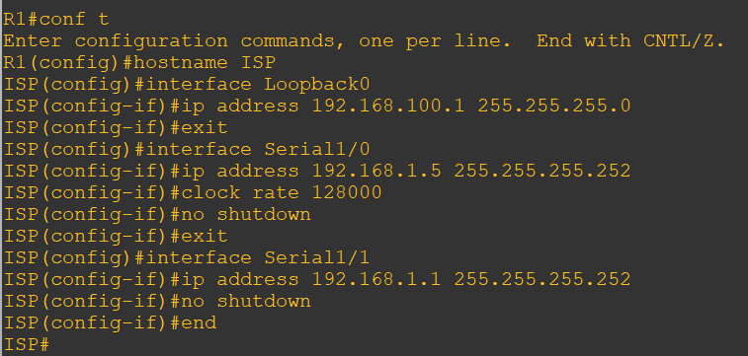

**R2 Console**

conf t

hostname SanJose1

interface Loopback0

ip address 172.16.64.1 255.255.255.0

exit

interface Serial1/0

ip address 192.168.1.6 255.255.255.252

no shutdown

exit

interface Serial1/1

ip address 172.16.1.1 255.255.255.0

clock rate 128000

no shutdown

end

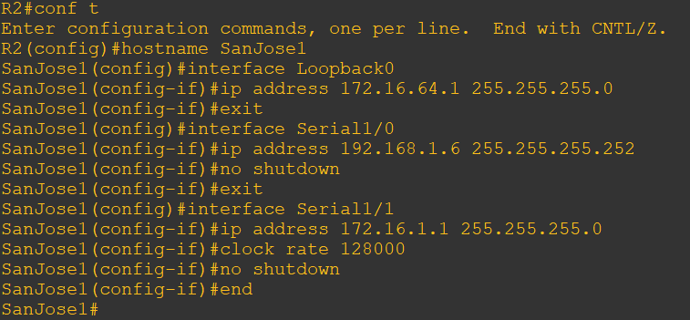

**R3 Console**

conf t

hostname SanJose2

interface Loopback0

ip address 172.16.32.1 255.255.255.0

exit

interface Serial1/1

ip address 192.168.1.2 255.255.255.252

clock rate 128000

no shutdown

exit

interface Serial1/0

ip address 172.16.1.2 255.255.255.0

no shutdown

end

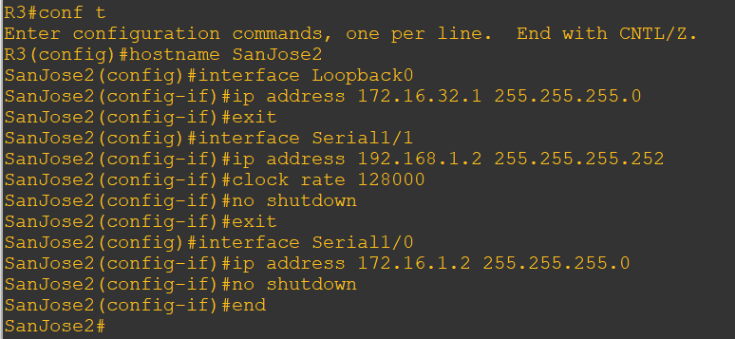

b. Use ping to test the connectivity between the directly connected routers. Both SanJose routers should be able to ping each other and their local ISP serial link IP address.

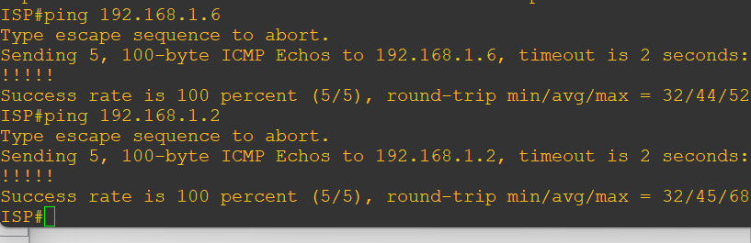

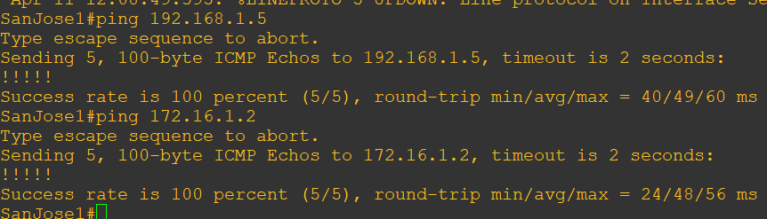

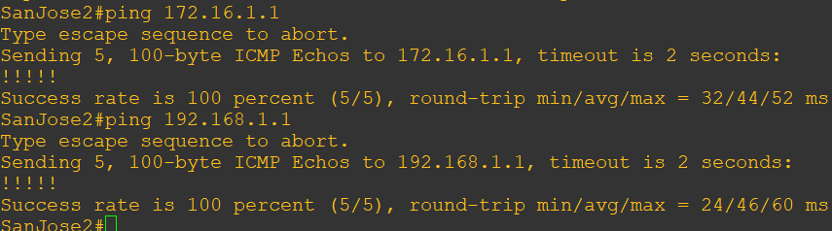

Step 2: Configure EIGRP.

Configure EIGRP between the SanJose1 and SanJose2 routers.

R2 and R3 Console

router eigrp 1

network 172.16.0.0

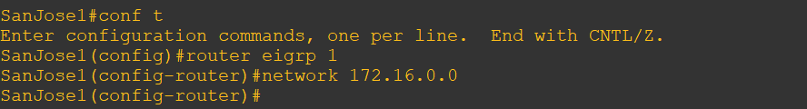

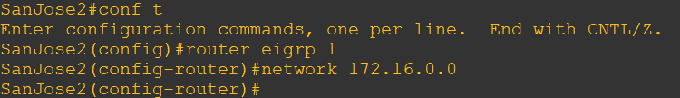

Step 3: Configure IBGP and verify BGP neighbors.

a. Configure IBGP between the SanJose1 and SanJose2 routers.

**R2(SanJose1) Console**

router bgp 64512

neighbor 172.16.32.1 remote-as 64512

neighbor 172.16.32.1 update-source lo0

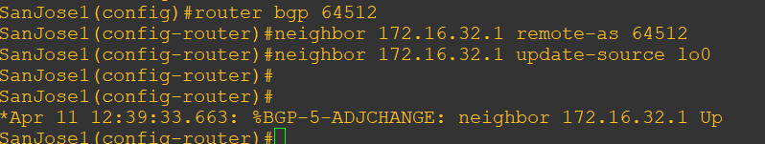

**R3(SanJose2) Console**

router bgp 64512

neighbor 172.16.64.1 remote-as 64512

neighbor 172.16.64.1 update-source lo0

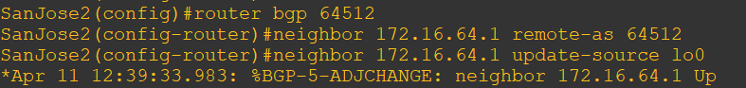

c. Verify that SanJose1 and SanJose2 become BGP neighbors by issuing the **show ip bgp neighbors** command on SanJose1.

**R2 and R3 Console**

show ip bgp neighbors

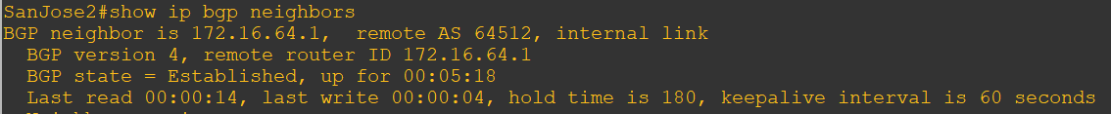

Note:- It should show internal link for successful bgp configuration

**Step 4: Configure EBGP and verify BGP neighbors.**

a. Configure ISP to run EBGP with SanJose1 and SanJose2.

**R1 (ISP) Console**

router bgp 200

neighbor 192.168.1.6 remote-as 64512

neighbor 192.168.1.2 remote-as 64512

network 192.168.100.0

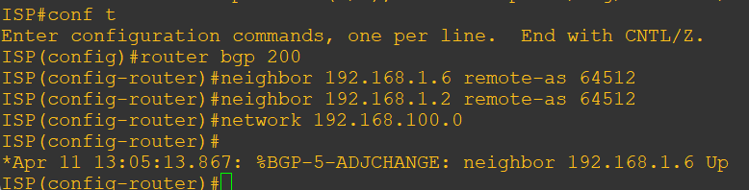

b. Configure a discard static route for the 172.16.0.0/16 network. Any packets that do not have a more specific match (longer match) for a 172.16.0.0 subnet will be dropped instead of sent to the ISP.

**R2 Console**

ip route 172.16.0.0 255.255.0.0 null0

c. Configure SanJose1 as an EBGP peer to ISP.

**R2 Console**

router bgp 64512

neighbor 192.168.1.5 remote-as 200

network 172.16.0.0

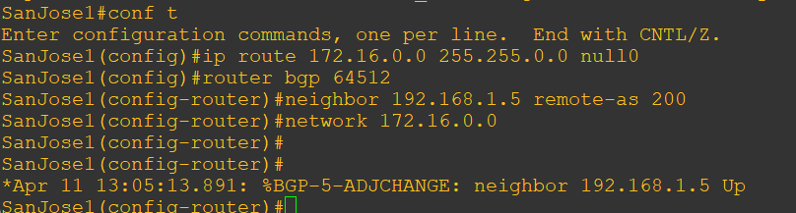

d. Use the **show ip bgp neighbors** command to verify that SanJose1 and ISP have reached the established state.

**R2 Console**

show ip bgp neighbors

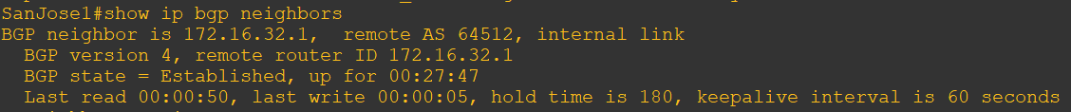



Note: - “external link” indicates that an EBGP peering session has been established.

e. Configure a discard static route for 172.16.0.0/16 on SanJose2 and as an EBGP peer to ISP.

**R3 (SanJose2) Console:**

ip route 172.16.0.0 255.255.0.0 null0

router bgp 64512

neighbor 192.168.1.1 remote-as 200

network 172.16.0.0

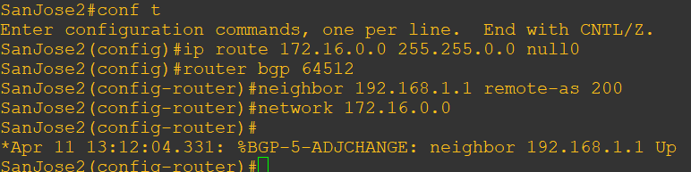

Step 5: View BGP summary output.

**R3 Console**

show ip bgp summary

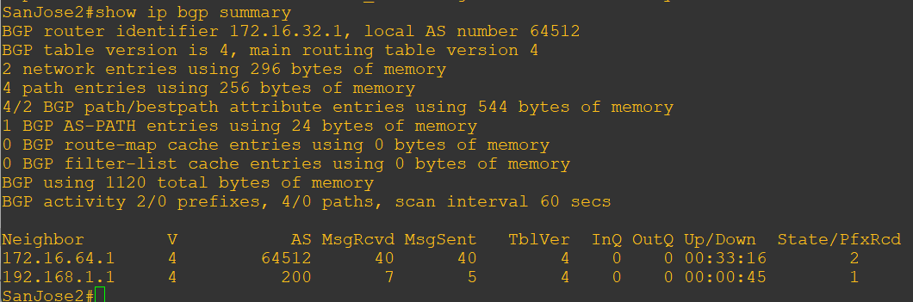

Step 6: Verify which path the traffic takes.

f. Clear the IP BGP conversation with the clear ip bgp * command on ISP.

**R1 (ISP) Console**

clear ip bgp *

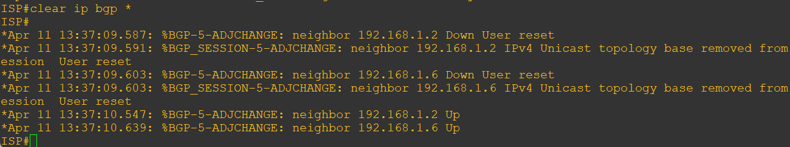

g. Test whether ISP can ping the loopback 0 address of 172.16.64.1 on SanJose1 and the serial link between SanJose1 and SanJose2, 172.16.1.1.

**R1 Console**

ping 172.16.64.1

ping 172.16.1.1

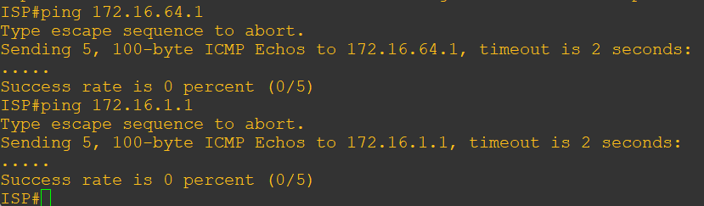

h. Now ping from ISP to the loopback 0 address of 172.16.32.1 on SanJose2 and the serial link between SanJose1 and SanJose2, 172.16.1.2.

**R1 Console**

ping 172.16.32.1

ping 172.16.1.2

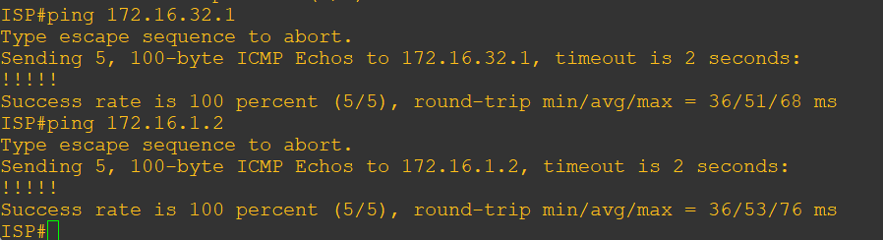

i. Issue the **show ip bgp** command on ISP to verify BGP routes and metrics.

**R1 Console**

show ip bgp

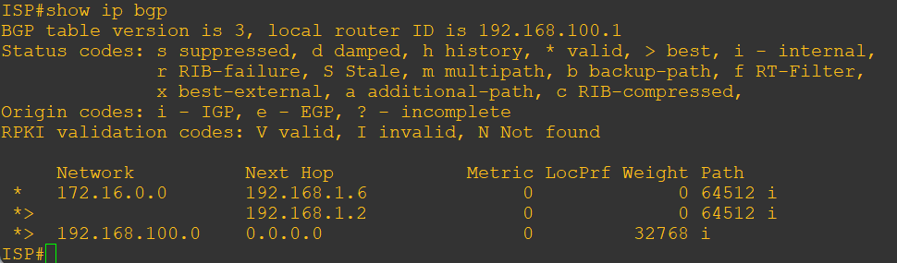

j. Use the extended ping command and specify the source address of ISP Lo0 to test.

**R1 Console**

ping 172.16.1.1 source 192.168.100.1

ping 172.16.32.1 source 192.168.100.1

ping 172.16.1.2 source 192.168.100.1

ping 172.16.64.1 source 192.168.100.1

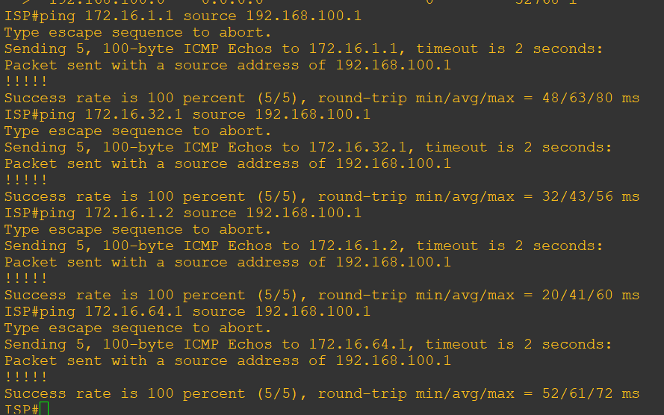

Step 7: Configure the BGP next-hop-self feature.

a. Issue the following commands on the ISP router.

**R1 Console**

router bgp 200

network 192.168.1.0 mask 255.255.255.252

network 192.168.1.4 mask 255.255.255.252

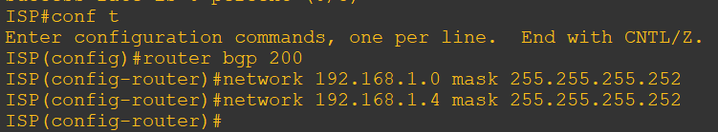

b. Issue the show ip bgp command to verify that the ISP is correctly injecting its own WAN links into BGP.

**R1 Console**

show ip bgp

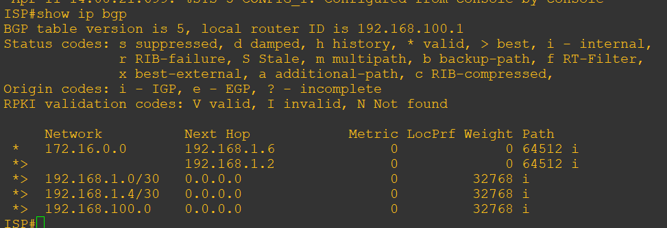

c. Verify on SanJose1 and SanJose2 that the opposite WAN link is included in the routing table.

**R2 and R3 Console**

show ip route

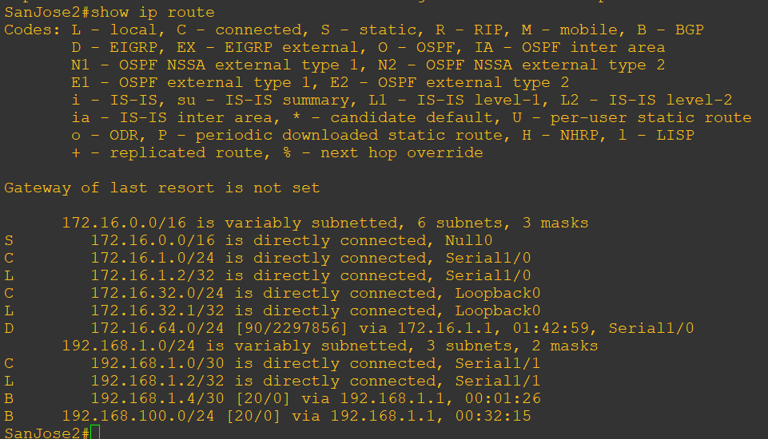

d. To better understand the next-hop-self command we will remove ISP advertising its two WAN links and shutdown the WAN link between ISP and SanJose2. The only possible path from SanJose2 to ISP’s 192.168.100.0/24 is through SanJose1.

**R1 Console**

router bgp 200

no network 192.168.1.0 mask 255.255.255.252

no network 192.168.1.4 mask 255.255.255.252

exit

interface serial 1/1

shutdown

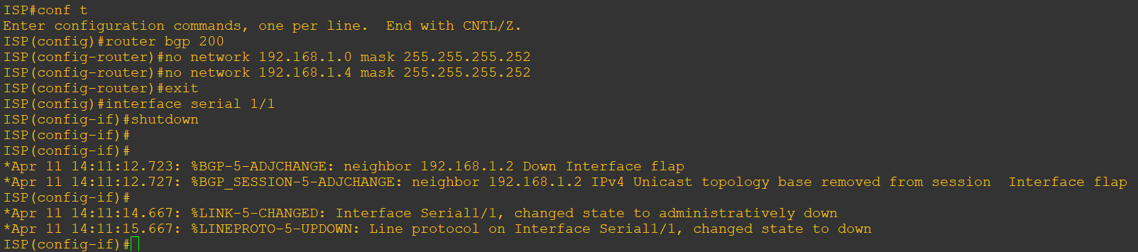

e. Display SanJose2’s BGP table using the **show ip bgp** command and the IPv4 routing table with **show ip route.**

**R3 (SanJose2) Console**

show ip bgp

show ip route

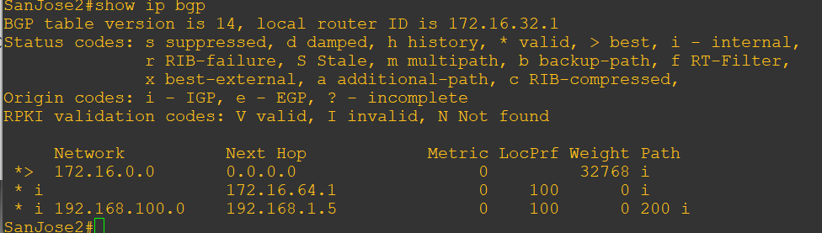

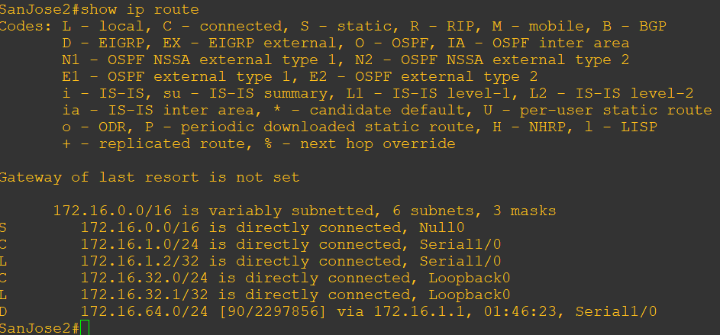

f. Issue the **next-hop-self** command on SanJose1 and SanJose2 to advertise themselves as the next hop to their IBGP peer.

**R2 Console**

router bgp 64512

neighbor 172.16.32.1 next-hop-self

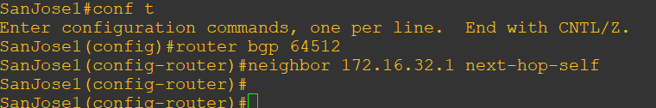

**R3 Console**

router bgp 64512

neighbor 172.16.64.1 next-hop-self

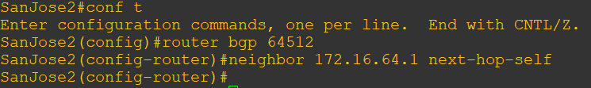

g. Reset BGP operation on either router with the **clear ip bgp \*** command.

**R2 and R3 Console**

clear ip bgp *

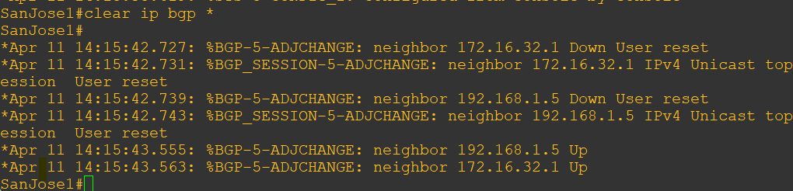

h. Issue the **show ip bgp** command on SanJose2 and notice that the next hop is now SanJose1 instead of ISP.

**R3 Console**

show ip bgp

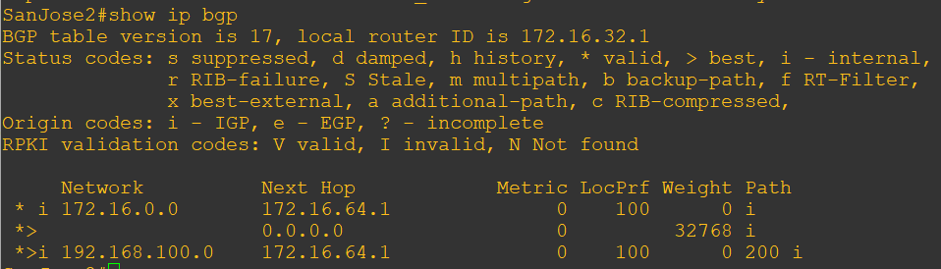

i. The show ip route command on SanJose2 now displays the 192.168.100.0/24 network because SanJose1 is the next hop, 172.16.64.1, which is reachable from SanJose2.

**R2 Console**

show ip route

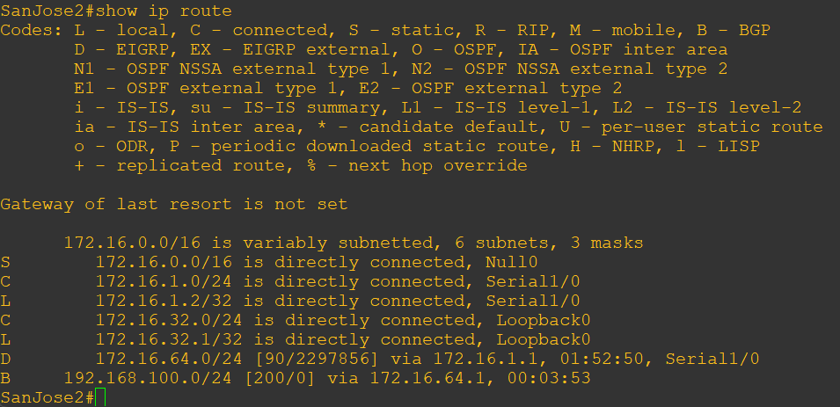

j. Before configuring the next BGP attribute, restore the WAN link between ISP and SanJose3. This will change the BGP table and routing table on both routers. For example, SanJose2’s routing table shows 192.168.100.0/24 will now have a better path through ISP.

**R1 Console**

interface serial 1/1

no shutdown

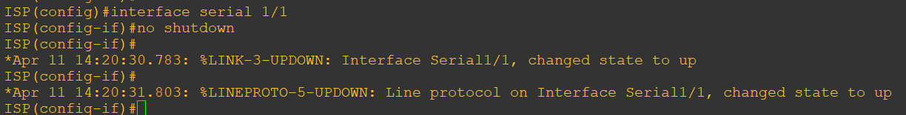

**R3 Console**

show ip route

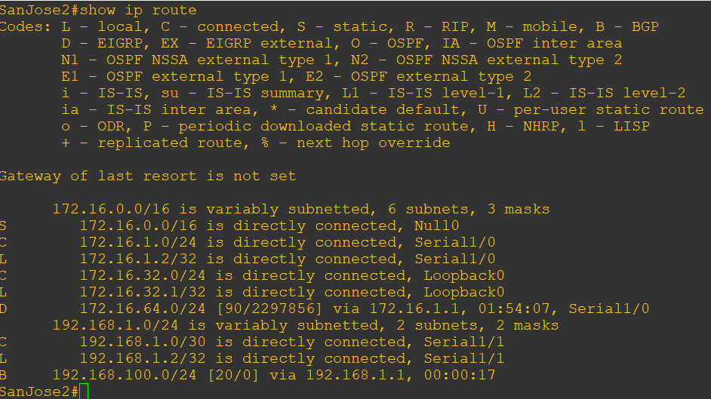

Step 8: Set BGP local preference.

a. Because the local preference value is shared between IBGP neighbors, configure a simple route map that references the local preference value on SanJose1 and SanJose2. This policy adjusts outbound traffic to prefer the link off the SanJose1 router instead of the metered T1 off SanJose2.

**R2 Console**

route-map PRIMARY_T1_IN permit 10

set local-preference 150

exit

router bgp 64512

neighbor 192.168.1.5 route-map PRIMARY_T1_IN in

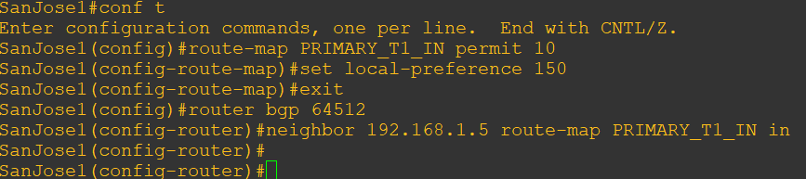

**R3 Console**

route-map SECONDARY_T1_IN permit 10

set local-preference 125

exit

router bgp 64512

neighbor 192.168.1.1 route-map SECONDARY_T1_IN in

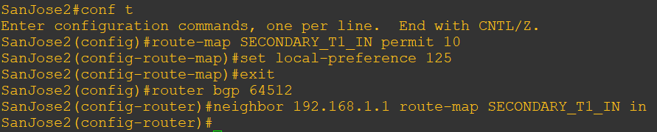

b. Use the **clear ip bgp \*** **soft** command after configuring this new policy. When the conversations have been reestablished, issue the show ip bgp command on SanJose1 and SanJose2.

**R2 and R3 Console**

clear ip bgp * soft

show ip bgp

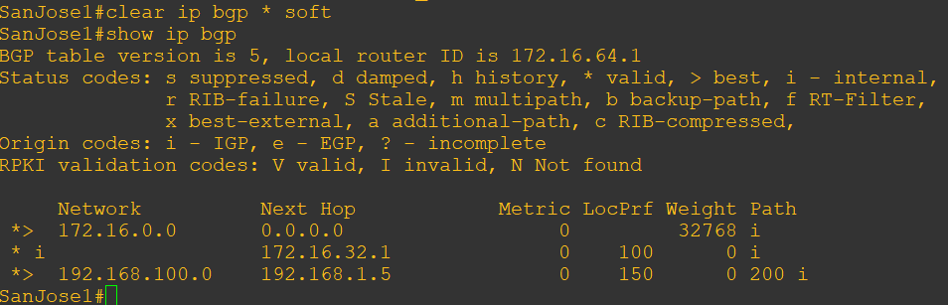

Step 9: Set BGP MED.

**R1 Console**

show ip bgp

show ip route

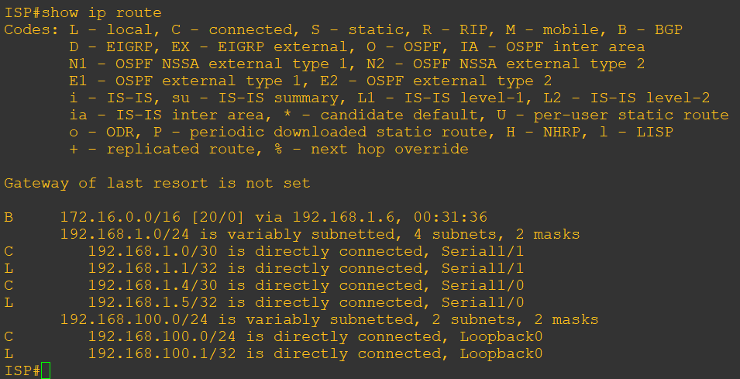

a. Use an extended ping command to verify this situation. Specify the record option and compare your output to the following. Notice the return path using the exit interface 192.168.1.1 to SanJose2.

**R3 Console**

Ping

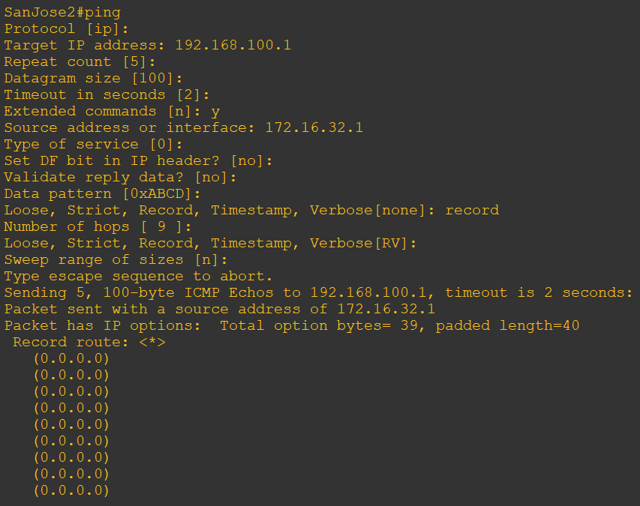 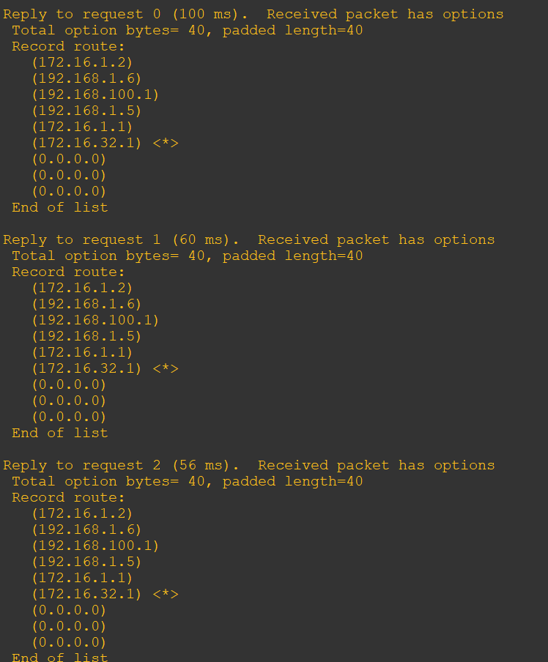

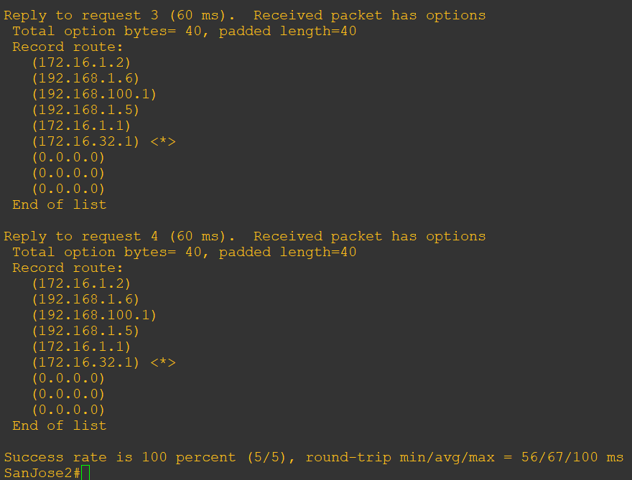

b. Create a new policy to force the ISP router to return all traffic via SanJose1. Create a second route map utilizing the MED (metric) that is shared between EBGP neighbors.

**R2 Console**

route-map PRIMARY_T1_MED_OUT permit 10

set Metric 50

exit

router bgp 64512

neighbor 192.168.1.5 route-map PRIMARY_T1_MED_OUT out

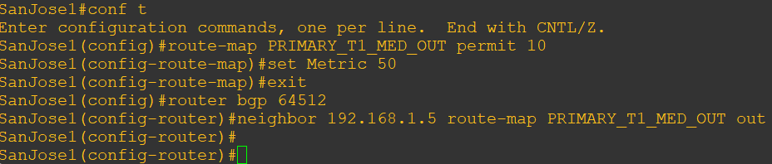

**R3 Console**

route-map SECONDARY_T1_MED_OUT permit 10

set Metric 75

exit

router bgp 64512

neighbor 192.168.1.1 route-map SECONDARY_T1_MED_OUT out

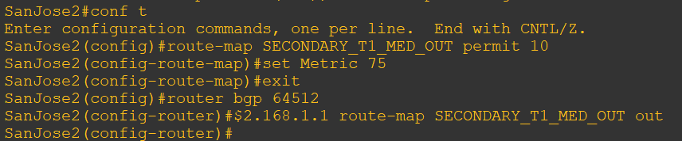

c. Use the **clear ip bgp * soft** command after issuing this new policy.

**R2 and R3 Console**

clear ip bgp * soft

show ip bgp

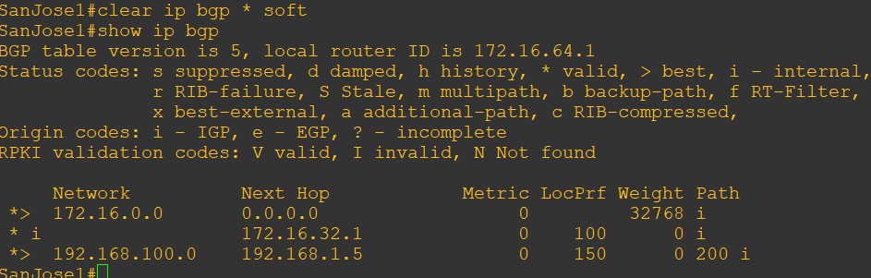

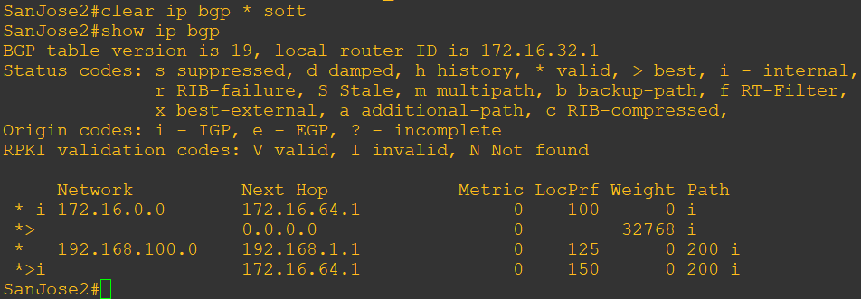

d. Reissue an extended **ping** command with the **record** command. Notice the change in return path using the exit interface 192.168.1.5 to SanJose1.

**R3 Console**

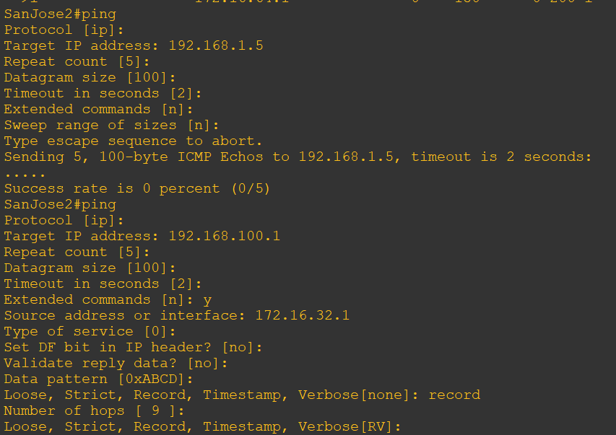

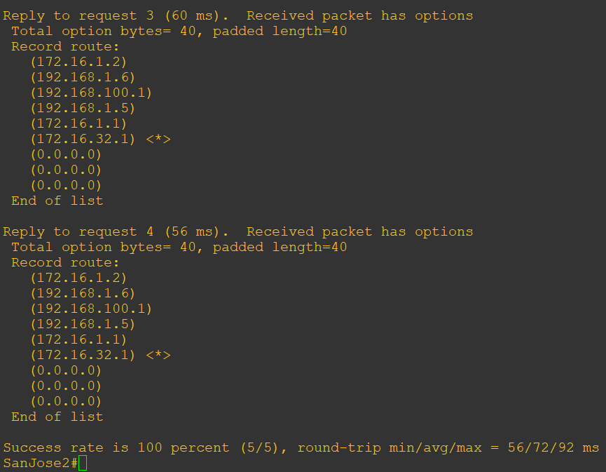

The newly configured policy MED shows that the lower MED value is considered best. The ISP now prefers the route with the lower MED value of 50 to AS 64512. This is just opposite from the local-preference command configured earlier.

**R1 Console**

show ip bgp

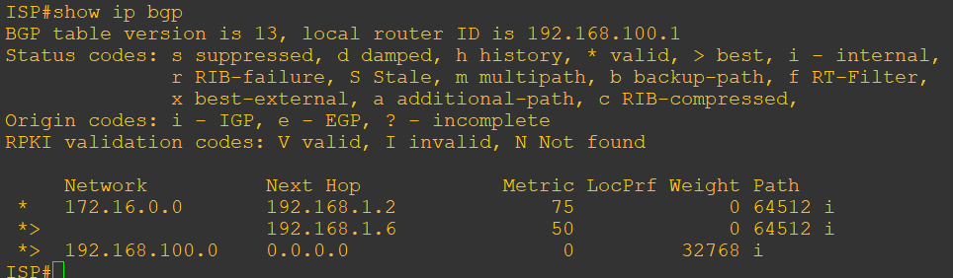

Step 10: Establish a default route.

a. Configure ISP to inject a default route to both SanJose1 and SanJose2 using BGP using the default-originate command.

**R1 Console**

router bgp 200

neighbor 192.168.1.6 default-originate

neighbor 192.168.1.2 default-originate

exit

interface loopback 10

ip address 10.0.0.1 255.255.255.0

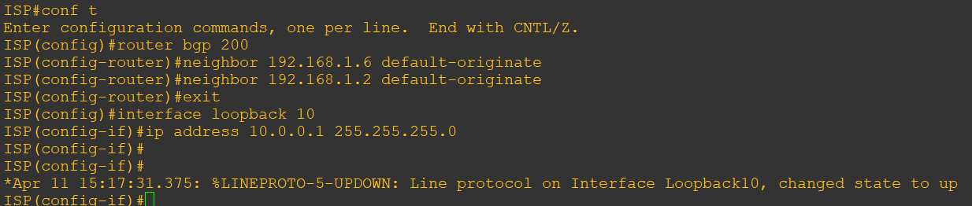

b. Verify that both routers have received the default route by examining the routing tables on SanJose1 and SanJose2.

**R2 and R3 Console**

show ip route

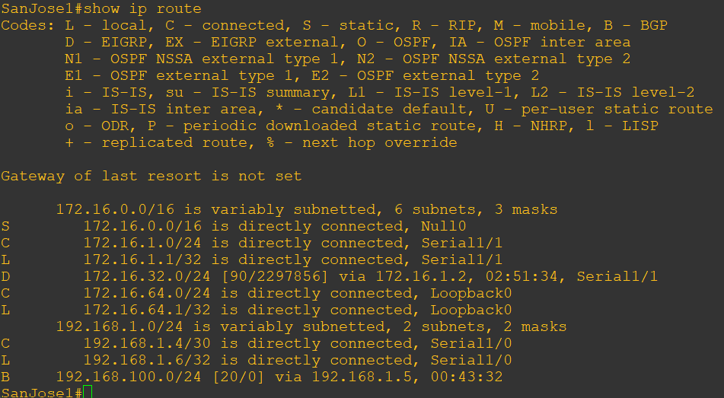

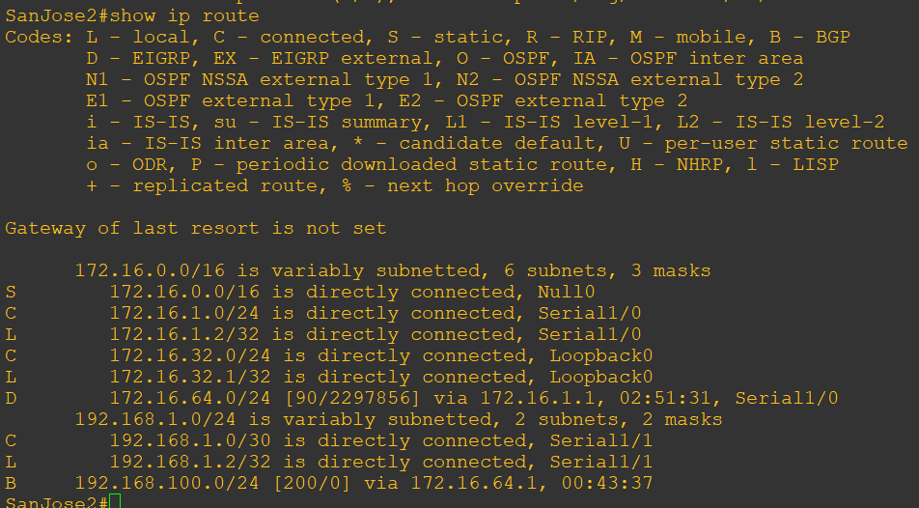

c. The preferred default route is by way of SanJose1 because of the higher local preference attribute configured on SanJose1 earlier.

**R3 Console**

show ip bgp

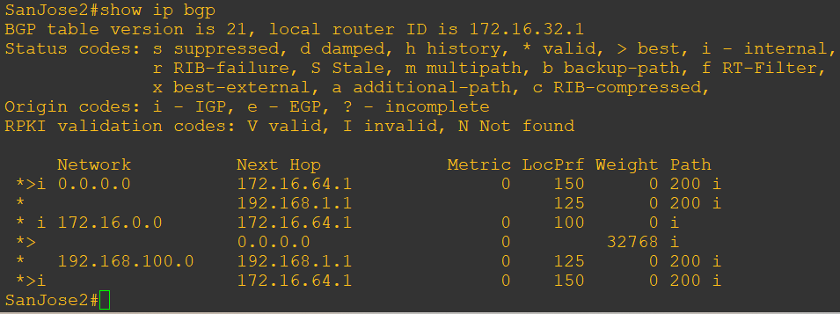

d. Using the traceroute command verify that packets to 10.0.0.1 is using the default route through SanJose1.

**R3 Console**

traceroute 10.0.0.1

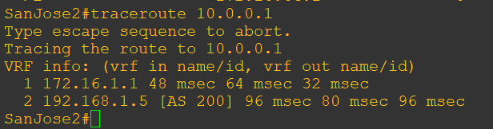

e. Next, test how BGP adapts to using a different default route when the path between SanJose1 and ISP goes down.

**R1 Console**

interface serial 1/0

shutdown

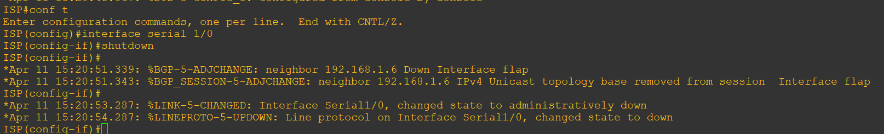

f. Verify that both routers are modified their routing tables with the default route using the path between SanJose2 and ISP.

**R2 and R3 Console**

show ip route

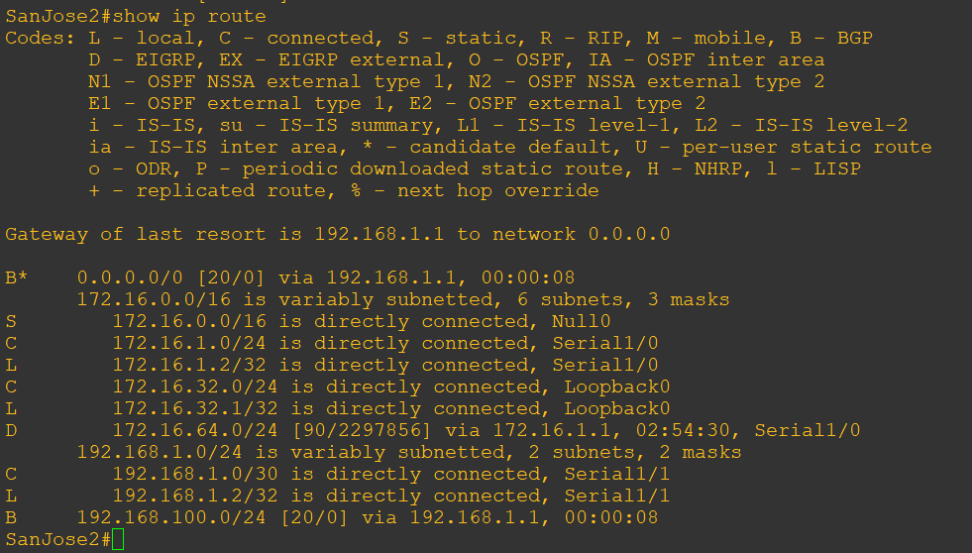

g. Verify the new path using the traceroute command to 10.0.0.1 from SanJose1. Notice the default route is now through SanJose2.

**R2 Console**

trace 10.0.0.1

